Mechanisms of Evolution
It is important to look at changes within a population of organisms. Individual organisms do not evolve!
Factors that could change the percentages of certain alleles within a population are the small events that lead to evolution within a population (microevolution).
1. Mutation-
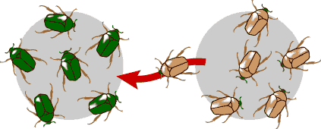
2. Gene Flow (immigration or emigration)-

3. Non-random mating-

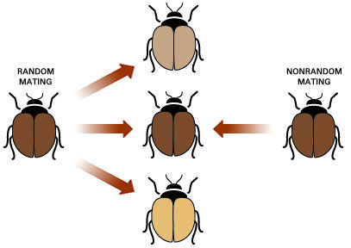
a) preferred phenotypes


b) inbreeding-

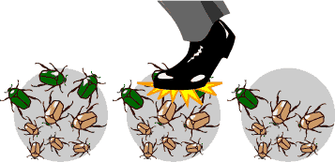
4. Genetic Drift

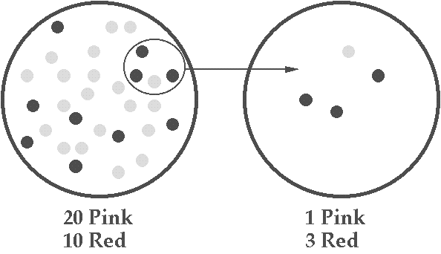
a) the founder effect-

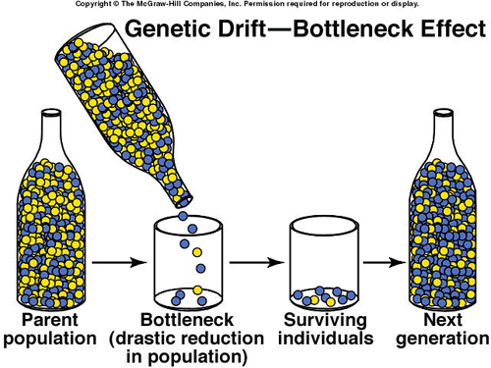
b) the bottleneck effect-

Natural Selection-

