Karyotypes
Prepared by:

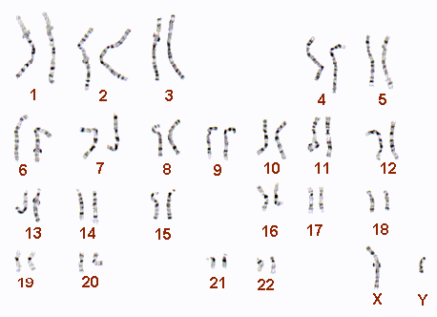

Autosomes-
Sex Chromosomes-
On what basis are the homologous chromosomes paired?
1)
2)
3)
Non-disjunction Disorders
What are they?

Why do they occur?

What is a syndrome?

Trisomy-

Monosomy-

Examples:
Chromosomes Abnormality | Name of Syndrome | Characteristics of Syndrome
XO

Trisomy 21

Trisomy 18

XXY

XYY

